Minutes of the Meeting of Glapwell Parish Council, held on Thursday 25th January 2024 in the Glapwell Centre, The Green, Glapwell.

**Members present:**

Cllrs T Trafford, C Fleetwood, J Ritchie, P Clough, D Harvey, I Grainger-Grimes, R Hibbert

**Apologies:**

County Cllr J Barron and PCSO D Hancock.

**In attendance:**

J Marriott (Responsible Finance Officer)

Dr J Clarke (Parish Clerk)

**Public Participation**

1 member of the public attended.

**BUSINESS**

**Public speaking**

A member of the public expressed her wish to be co-opted on to the parish council. The Chair thanked her for her interest, asked her to put her wish in writing and then it would be discussed at the next Parish meeting.

Concern was also expressed about the amount of dog mess around the village. Cllr Ritchie said he would ask Bolsover District Council (BDC) to do some patrols in the area. The Clerk would order some signs to post about the village.

The swing-tyre on the children’s area has not yet been replaced so the Clerk would chase this up with BDC. The Clerk would also make enquires as to whether the playground could be refurbished by some of the monies attached to the Glapwell Nurseries development.

**01/****01/24 Apologies for absence**

Cllr J Barron and PCSP D Hancock.

**02/01/24 To receive declarations of interests**

Cllrs Trafford and Fleetwood declared a personal interest as Trustees of the Glapwell Guardians.

All councillors present declared a personal interest in the Glapwell Community Sports Association.

Cllr Ritchie declared a personal interest in Glapwell Cricket Club.

**03/01/24 Minutes**

**RESOLVED That:** these minutes were approved as an accurate record of the meeting held on 23rd November 2023.

**04/01/24 Exclusion of Public**

The discussion about Hall Corner was moved into confidential items.

**05/01/24 Reports**

1. **Parish Clerk’s report**

A written report was submitted including an update on the new roof, the sports hall kitchen and the newly installed boiler.

It was agreed the Clerk would liaise with Wednesday Wanderers (WW) to ascertain where they were in securing a defibrillator for Hall Corner. The Parish would also proceed with a successful application for a British Heart Foundation grant for a defibrillator. If WW were successful in locating one for the football ground, then the second defibrillator would be located at the Cricket Ground.

Ault Hucknall Parochial Church Council had requested financial support to help with the upkeep of the church grounds. It was agreed that the parish would point them in the direction of the Community Payback scheme to get some help.

1. **District Councilor’s report**

A written report was submitted**.**

1. **County Councilor’s report**

Cllr Barron was not present. The Clerk was asked to contact Cllr Barron about the dangerous junction near the Young Vanish.

1. **Police Report**

No report had been submitted.

1. **Glapwell Centre Manager’s report**

The Manager’s report concentrated on the cash income for the Guardians and the Sports ground which was increasing as use of the centre and MUGA was continuing to grow.

The centre had been recently redecorated and councillors asked whether it was wise to redecorate whilst the roof was being replaced. The Clerk said she would raise this with the staff.

**06/01/24 Planning**

No new applications.

**07/01/24 Items for Consideration and Decision**

- **Renovation of the community centre (standing item).**

It was agreed that an Expression of Interest should be submitted to the Community Ownership Fund for a new community centre.

* **Notice boards.** It was agreed that the Parish would advertise on social media for someone to build replacement noticeboards.

**RESOLVED That:**

**08/01/24 Items for Information Only**

1. **Correspondence**

None received

1. **Items for Information**

None received

**09/01/24 Finance**

1. Payments for authorisation

Council received the list of payments for authorisation for approval.

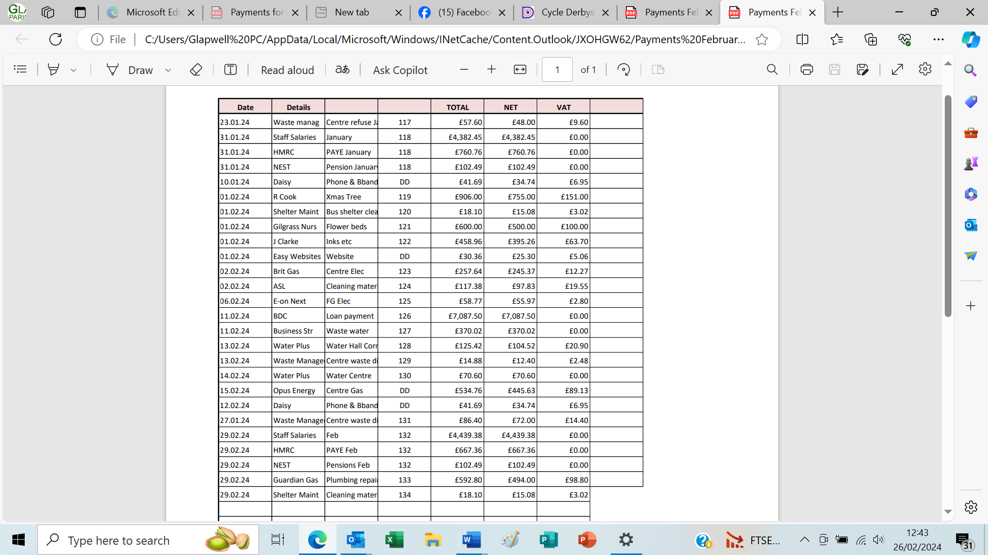

1. Income and expenditure, bank reconciliation

**Resolved that:** these are received and approved

**10/01/24 Items to be included on the next agenda (Thursday 29th February 2024)**

**Easter activities, Cultural Corridor**

**In confidence**

**07/01/24**

* **Hall Corner and MUGA (standing item)**

**Resolved that:**

1. All councillors would be invited to a site visit of Hall Corner and the MUGA
2. The volunteer groundsman would be invited to meet the councillors at the next Parish meeting
3. CCTV should be reinstalled at Hall Corner
4. The Parish would hold a full set of keys for the ground.

**Meeting closed at 9.32pm**

**Chair:_________________________________________ Date:________________________**